File Size Optimization for Collection Icons

As you create collection icons, push them through a workflow that minimizes the file size.  When the Portal and DL were designed, no one used mobile devices.  Now lots of people do, and the size of images really matters in some cases. For background: many web pages in the wild hover between 1.5 and 2.5 MB nowadays. The bigger the slower (more expensive) for people on fixed data plans or with limited connectivity.

When a user views one of our single collection pages, the data footprint for a collection icon is negligible, but when they visit the main /collections page that has all 300+ images, those kilobytes add up quickly.  As part of our redesign efforts we ran a batch process to crunch all the existing collection icons and reduced the page load by about 3MB. The original file sizes ranged from 10KB to 144KB per image and now they are between 2KB and 19KB. The current live Portal comes in at a 5.0 MB download for the entire collections page, which is still pretty heavy. And remember, these are decorative images, not essential.  Most people’s eyes will scan, note them in less than a second, and move on.

# Image Considerations

The weightiest images on average are those that tend to look like this (lots of super fine details/contrasting colors, hard pixels).  In fact, nearly everything in the top half of file sizes of the 300+ icons are newspapers with big blocks of fine text.

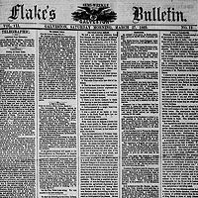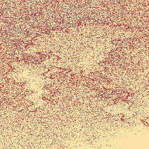

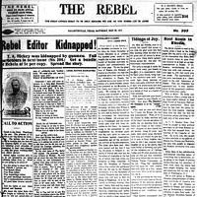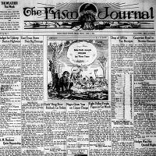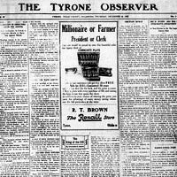

Images with fewer contrasting pixels and more blurring often come with significant savings. Nearly everything in the lower half of file sizes for the 300+ icons are photos or texts where there are either fewer tiny words, or blurred copy:

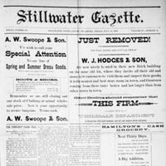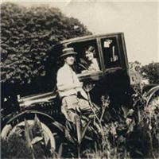

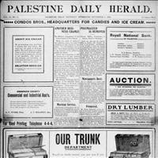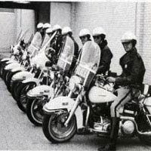

The lightest footprints, no surprise, are for images which lack much detail, vector-like images, or other images where color contrast/blurring of pixel values is significant:

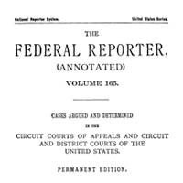

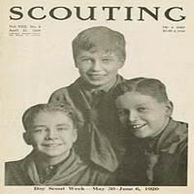

Finally, do note that even though you are saving images at 200x200 pixels, the viewed size is going be highly variable going forward.  Since the new site is responsive to the web browser’s viewport width, the image may grow or shrink.  At their smallest, the icons will render at about 85x85 pixels and there is no theoretical limit to their largest size, though on a current Mac at full resolution this is about 350x350.  To add to the complexity, modern browsers will attempt to blur images as they grow beyond their natural size instead of rendering with the big, blocky pixelation of days gone by.

# How to Refine and Save

Your goal will be to get a final output of less than 20KB, the lower the better, as long as it still looks acceptable to you.

In Photoshop:

1. Use **Save for Web.**  Not Save or Save As. [In Photoshop, go to File>Export>Save for Web (Legacy)]
2. Do a four-up comparison and fool around with options for the different preview panes to see what works for you.
   1. Progressive is usually helpful.
   2. A JPEG of maybe 40-50% of the original may make sense.
   3. Blurring may be nice.
   4. Check the box Yes for sRGB.
   5. Metadata: None!

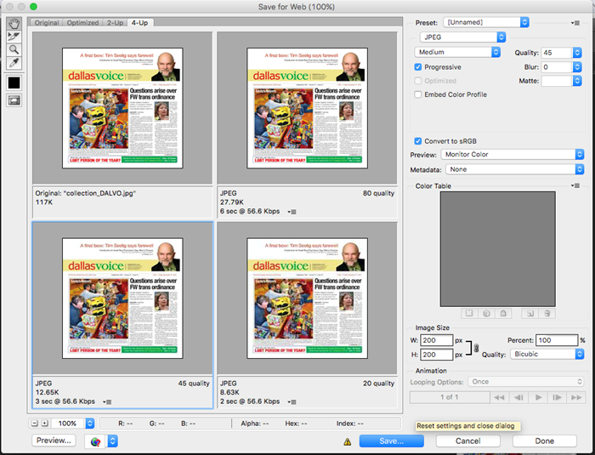

There are a few other tools that can do this sort of work for you, but this is straightforward and customizable for us. Anyway, the Internet will thank you.