Guidelines for Collection Descriptions

rev03_2020-05

Short Descriptions
Construct short descriptions that intrigue the reader and clearly communicate the content of the collection.
- Limit to no more than 328 characters with spaces (about 55 words).
- Vary word order so that all the collections on the page don’t sound the same.
- Focus on the theme of the digital collection.
- Use dates and numbers judiciously—they may require updating if the collection expands.
- Acknowledge grant funding where appropriate.
- If access to the collection is restricted, include an access disclaimer.
- Italicize publication titles in the short description text.
- Do not include hyperlinks.
- Do not introduce or discuss the partner(s) associated with the collection (exception – umbrella collections such as Rescuing Texas History).

Collection Icons
Select or create images that are visually interesting, represent the collection, are suitable for all audiences, and have a minimal file size.
- 200 x 200 pixels
- JPEG file 20KB or smaller

Long Descriptions
When information is available, construct long descriptions that provide additional details and context for the collection.
- Generally limit to 500 words.
- Employ headings and bullet points to define content. Use Markdown heading #3 (###).
- Focus on the digital collection.
- If needed for context, include information about history, issuing agencies, title changes, access, parent collection, project details, or acknowledgements.
- Italicize publication titles in the long description text.
- Limit use of hyperlinks. Embed any links in text rather than listing the URLs.
- Do not profile the associated partner(s) here unless needed to provide context for the collection.

Some Caveats
Write descriptions with an eye to longevity so we can avoid continual correction. Something you describe as “new” won’t be in five years. Likewise, the number of items or dates covered may change over time as more items are added to the collection.
Be aware of information such as partners, dates, or geographic coverage that is automatically appended to the long description.
Partners sometimes have very specific ideas about their partner and collection descriptions. Negotiation and/or bending the rules may be required for good partner relations. Use good judgment.
NDNP-funded newspaper collections may have commissioned essays that exceed the 500-word limit for long descriptions.

Examples

When the short description is too long, condense by focusing on key facts about the collection.
Original:
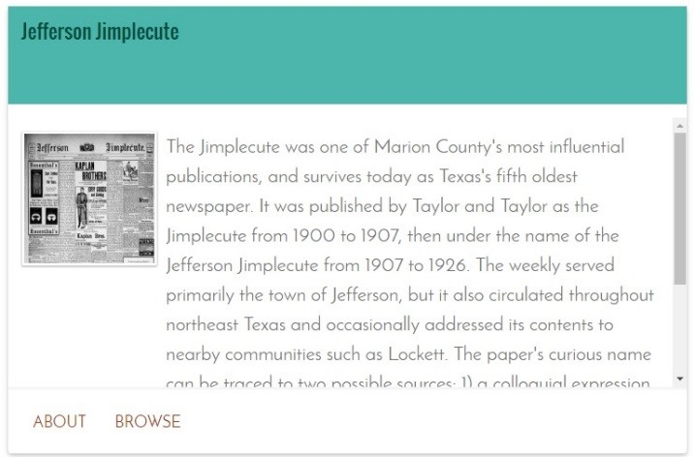
Better:
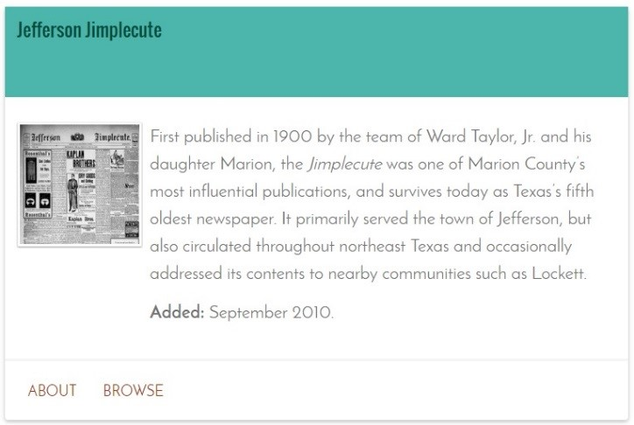
To avoid phrases like “this collection features,” plainly list the contents of collection.
Original:
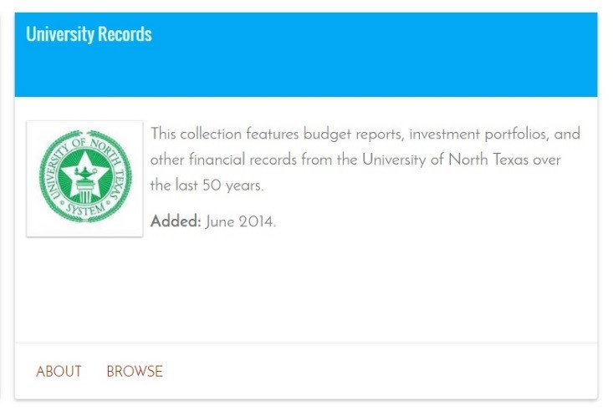
Better:
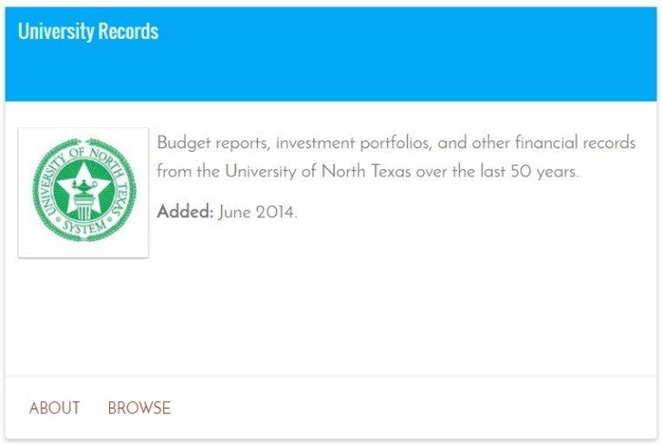

Reword short descriptions to avoid phrases like “this collection features” and indicate restricted items by using boldface type.
Original:
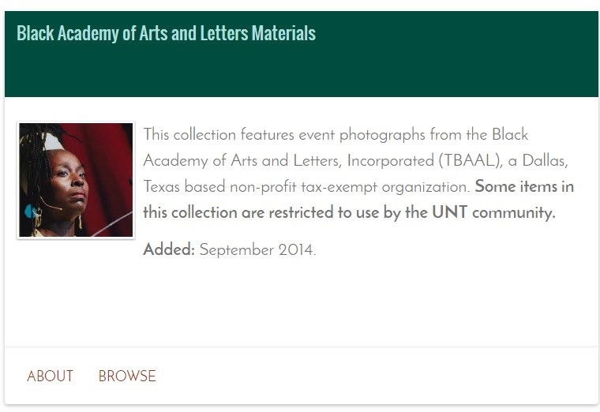
Better:
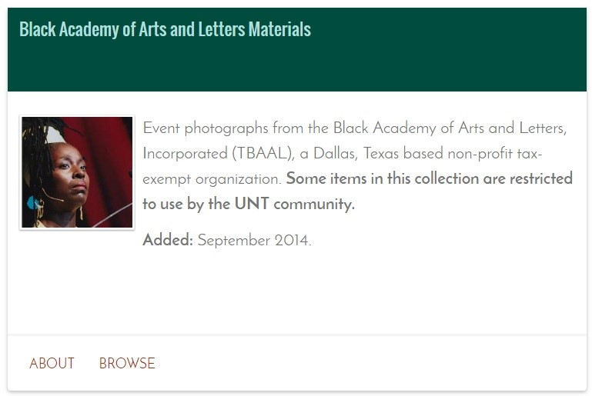
When the short description focuses more on the partner than on the collection, reword to focus on important information about the collection. Incorporate special funding into the short description.
Original:
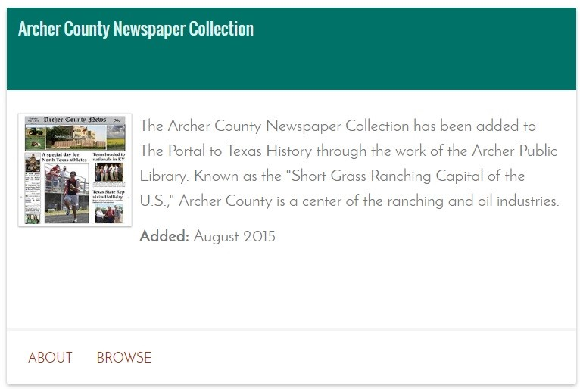
Better:
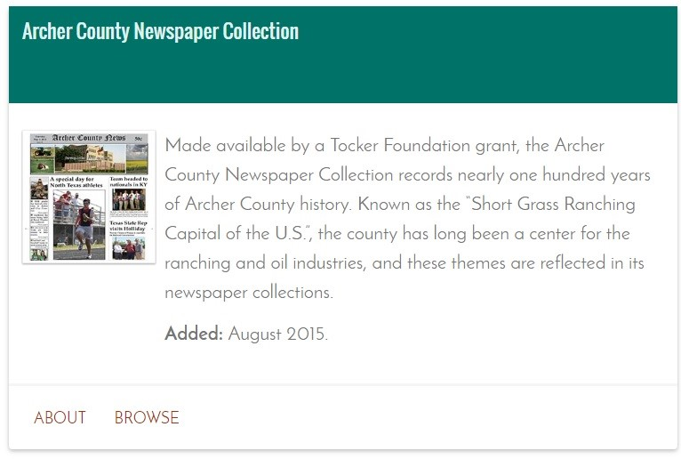

Reword short descriptions to avoid phrases such as “[partner] presents.” Also avoid listing the number of items in the collection.
Original:
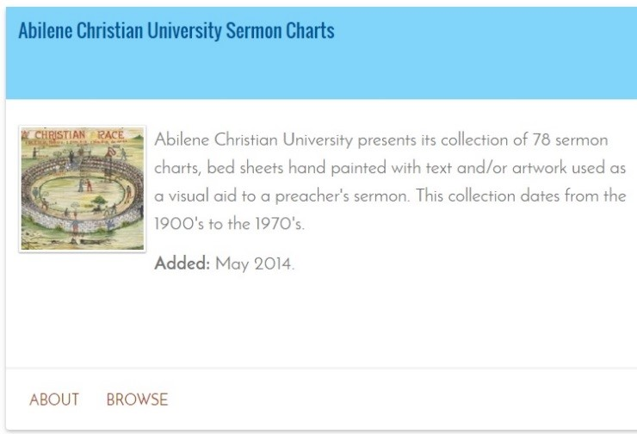
Better:
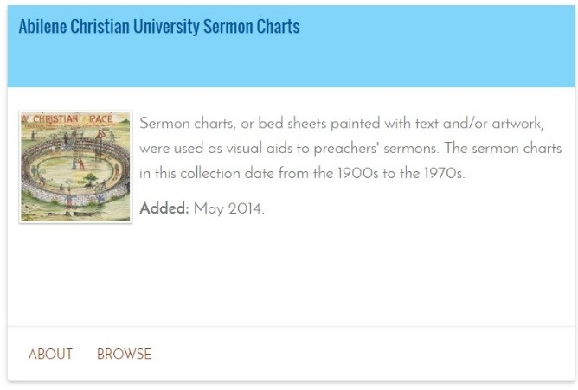
Organize existing long descriptions by using headings.
Original:
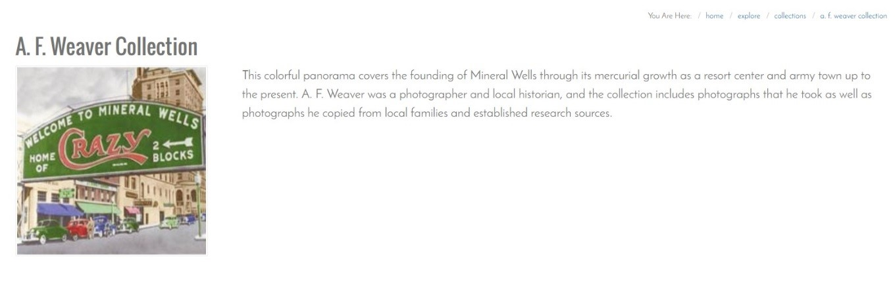
Better:
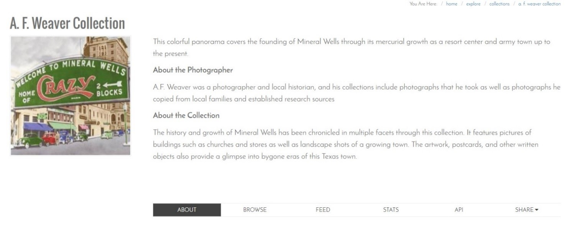
Use headings to break up long descriptions.
Original:
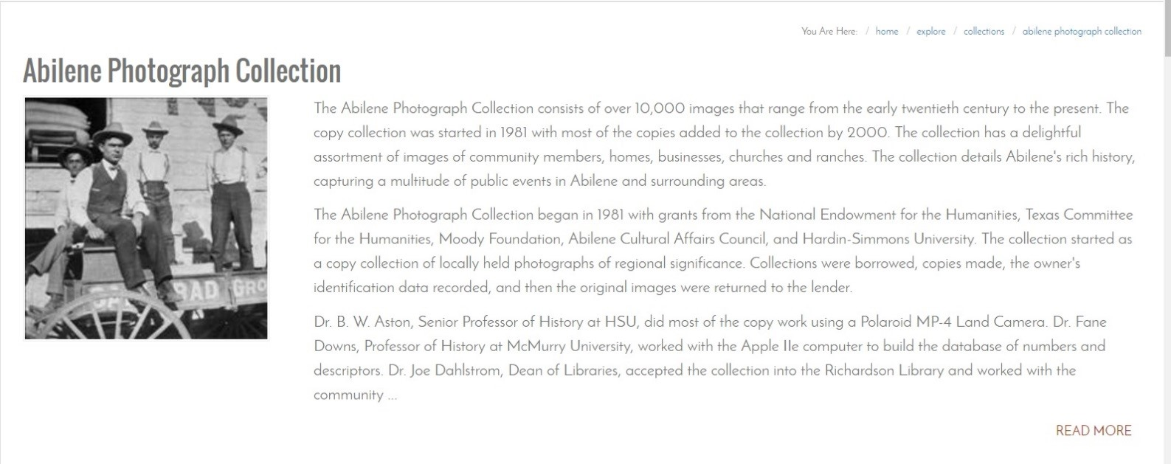
Better:
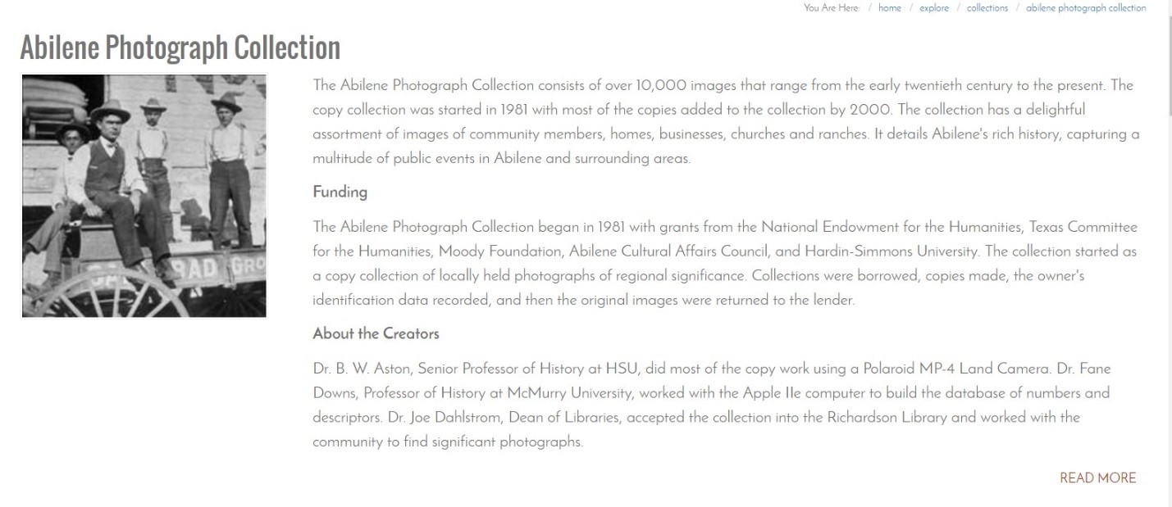
When the listing of partners is unavoidable, use bulleted lists to organize information.
Original:
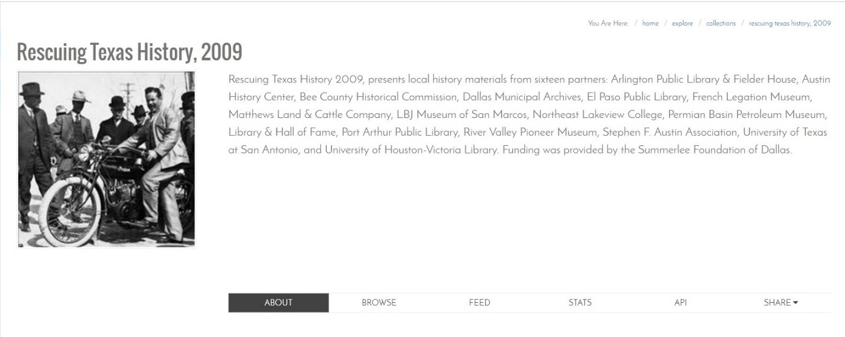
Better:
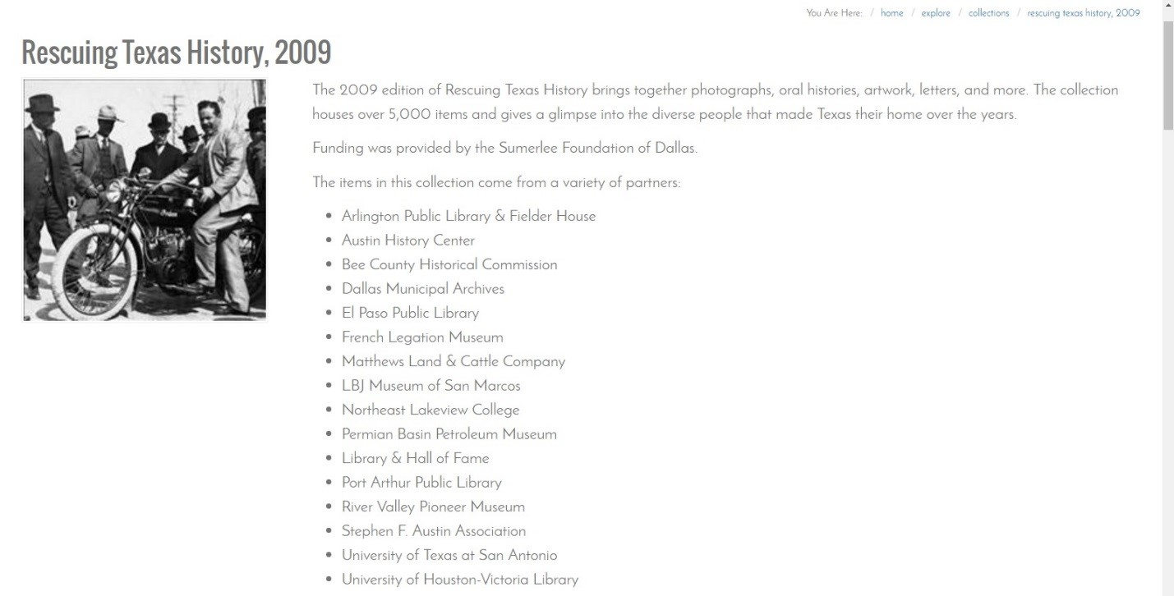
When revising both short and long descriptions for the same collection, focus on key facts about the collection in the short description and incorporate any special funding. Use headings in the long description to create structure and a logical flow of information.
Original short description:
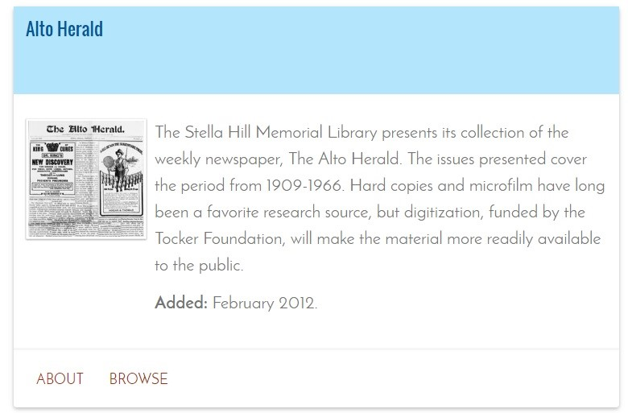
Better short description:
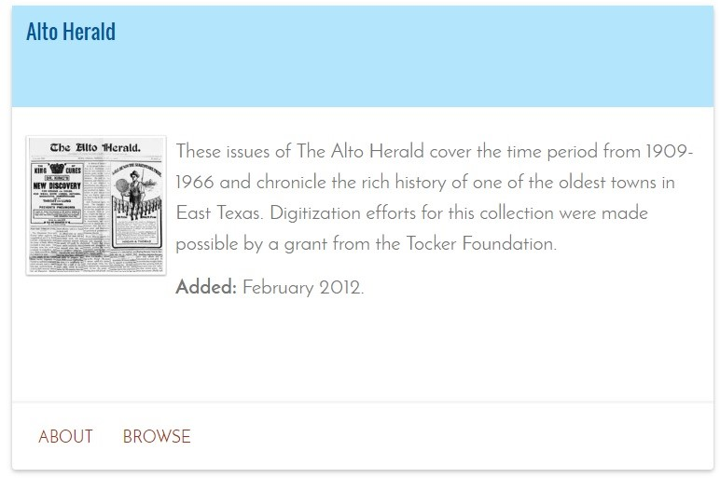
Original long description:
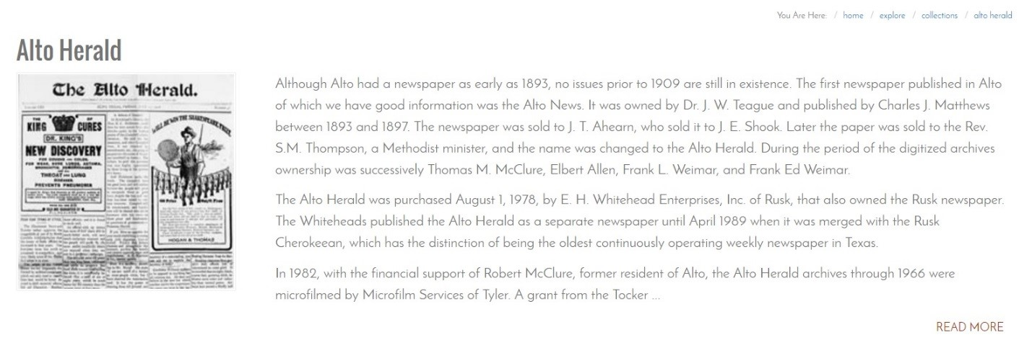
Better long description:
