Guidelines for Partner Descriptions

rev02_2020-05

Short Descriptions
Construct short descriptions that provide a brief overview of the individual, institution, or department.
- Limit to no more than 328 characters with spaces (about 55 words).
- Vary word order so that all the partners on the page don’t sound the same.
- Focus on the partner’s purpose—what the partner does.
- Include interesting facts about the partner.
- Acknowledge any financial support the partner has provided to the PTH/DL.
- Italicize publication titles in the short description text.
- Do not include hyperlinks.
- Do not describe our digital collections associated with the partner.

Partner Icons
We will not add icons to the partner records.

Long Descriptions
When information is available, construct long descriptions that expand upon the information in the short description.
- Generally, limit to 500 words.
- Employ headings and bullet points to define content.
  - Use Heading 3 (“### text” in Markdown) for headings.
  - Stick to short, clear phrases such as “About the Partner,” “History,” “Funding,” etc.
- Emphasize the purpose, goals, and activities of the partner.
- If needed for context or interest, include information about history, funding, and service area/audience.
- Italicize publication titles in the long description text.
- Limit use of hyperlinks. Embed any links in text rather than listing the URLs.
- Do not profile the associated collection(s) here.
- When entering the description into the system, also complete the longitude and latitude fields to produce an accurate map location for the partner. (A finder tool is available in the partner description entry form.)
- If no long description is provided, the system will repeat the short description here.

Some Caveats
Write descriptions with an eye to longevity so we can avoid continual correction. Something you would describe as “new” won’t be in five years.
Be aware of information such as collections or contact information that is automatically appended to the long description.
Partners sometimes have very specific ideas about their partner and collection descriptions. Negotiation and/or bending the rules may be required for good partner relations. Use good judgment.

Examples

When the short description is too long, condense by focusing on most important points.
Original:
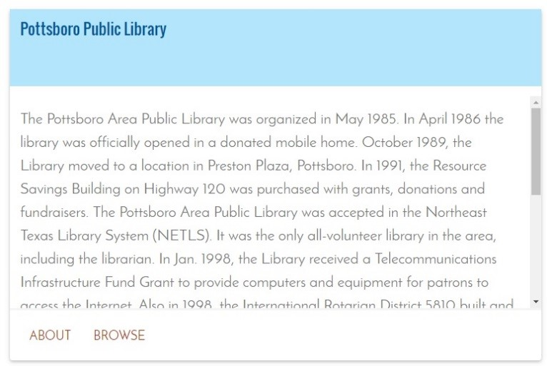
Better:
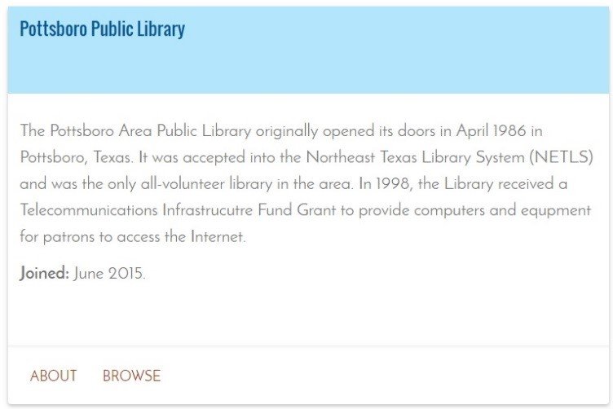
When the short description is too short and/or focuses too heavily on the digital collection, use information from the partner’s website to flesh it out. Avoid usage of phrases such as “[partner] presents.”
Original:
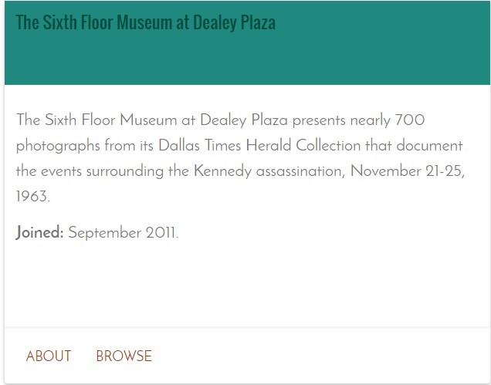
Better:
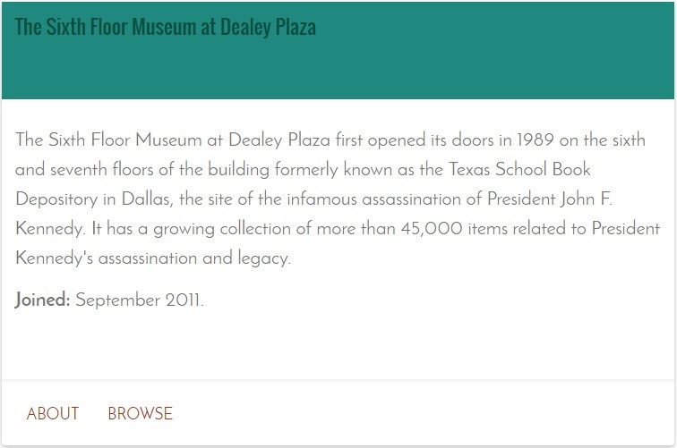
When the short description focuses solely on the collection, reword it to center on the partner.
Change the wording of short descriptions that use phrases such as “this partner presents.”
Original:
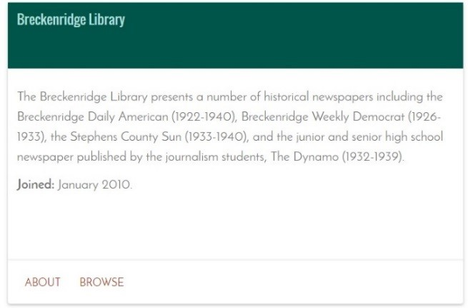
Better:
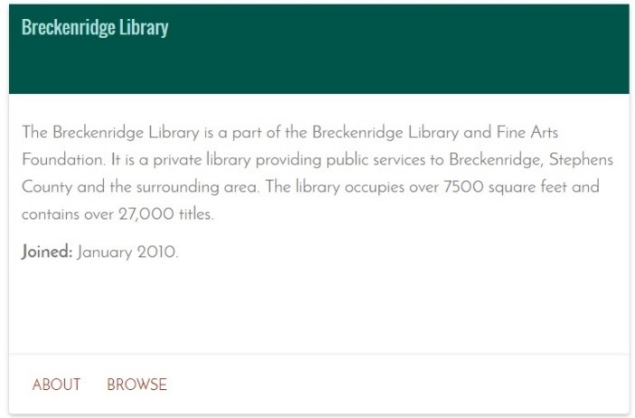
If the partner’s contribution to The Portal is the result of a grant or another type of special funding, incorporate the funding in the short description.
Original:
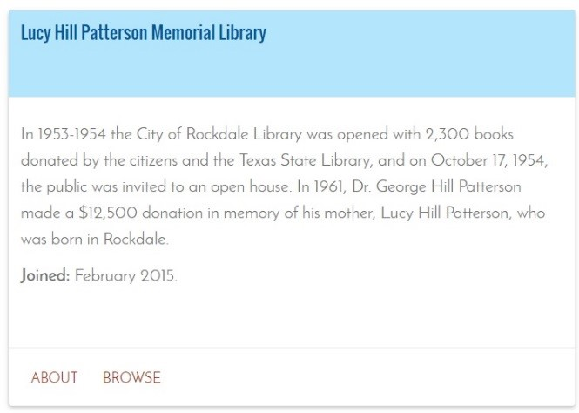
Better:
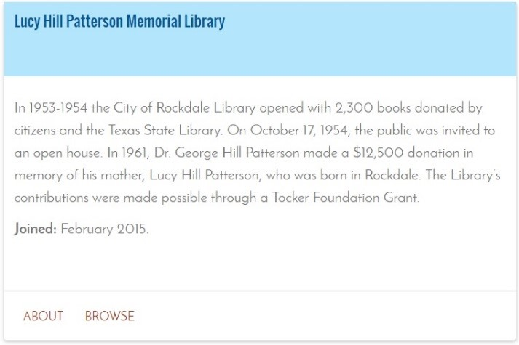
Use headings to break up blocks of text in the long description.
Original:
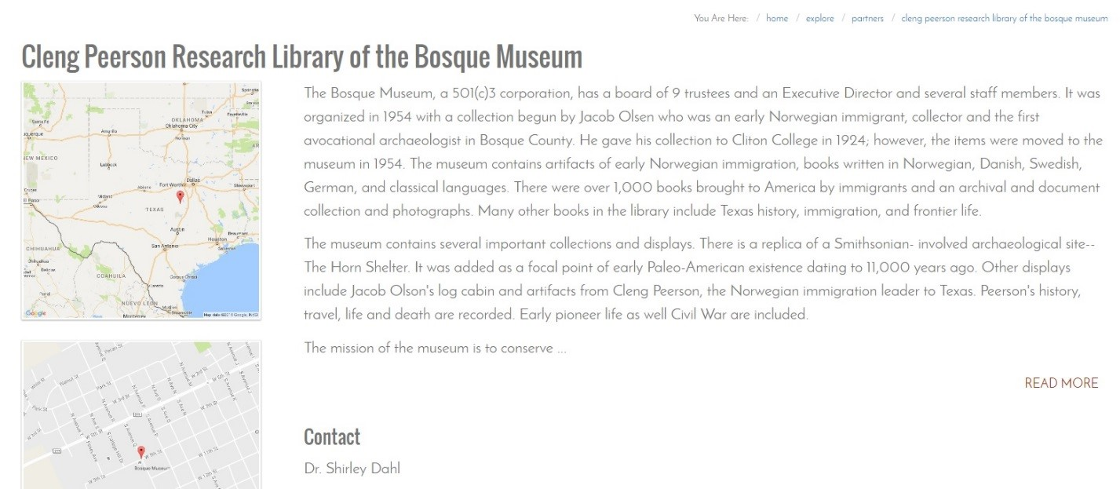
Better:
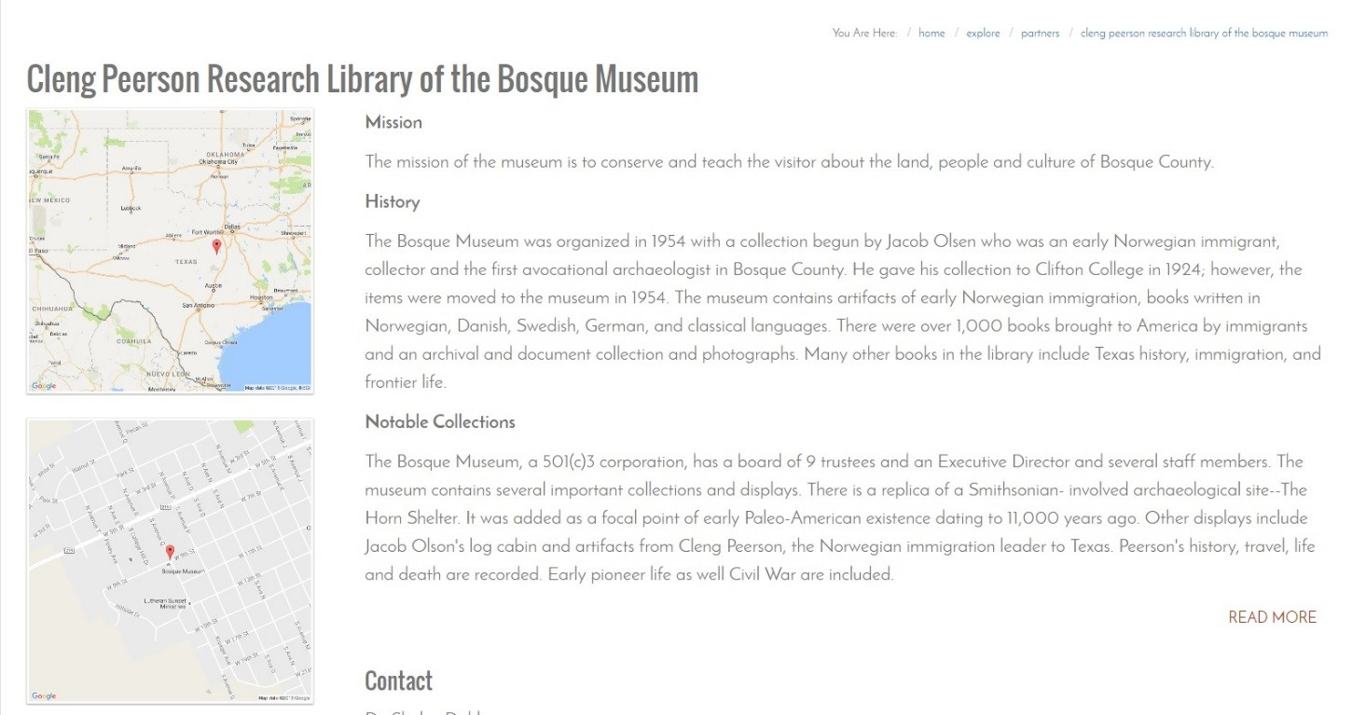
When the long description is carried over from the short description and/or provides an insufficient amount of information, augment with information from the partner’s website where possible.
Original:
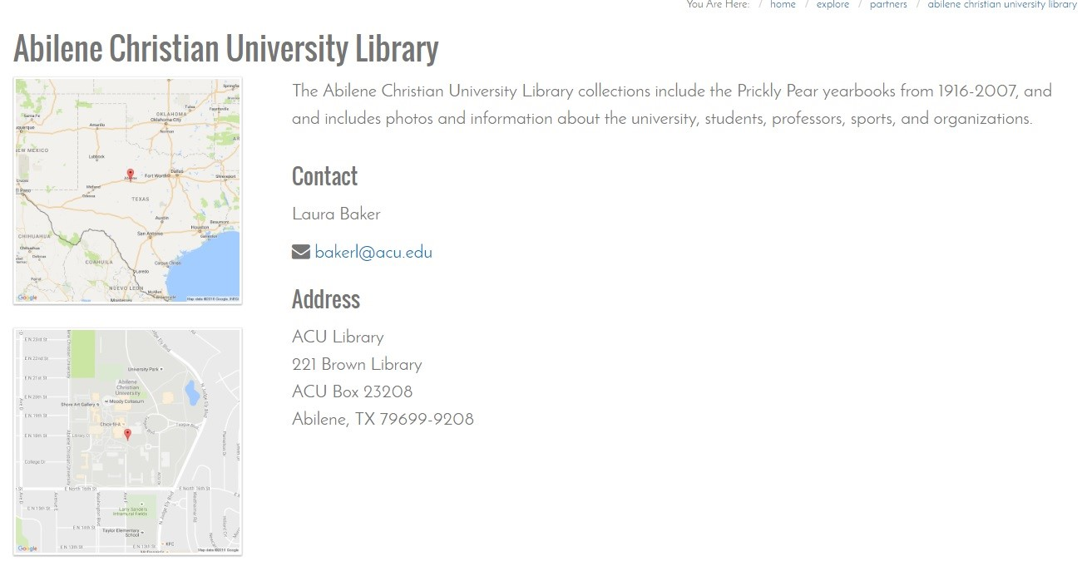
Better:
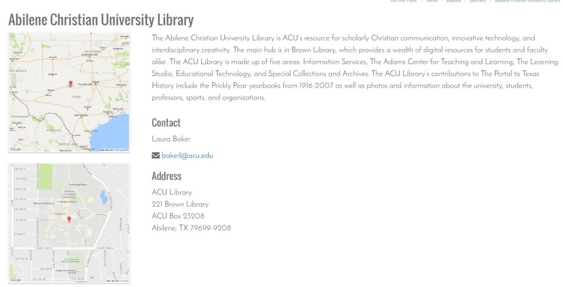
When revising both short and long descriptions of the same partner, incorporate main points in the short description and go into further detail about the partner in the long description. Incorporate information about funding in the short description. Use headings in the long description to expand upon points in the short description and create a logical structure of information.
Original short description:
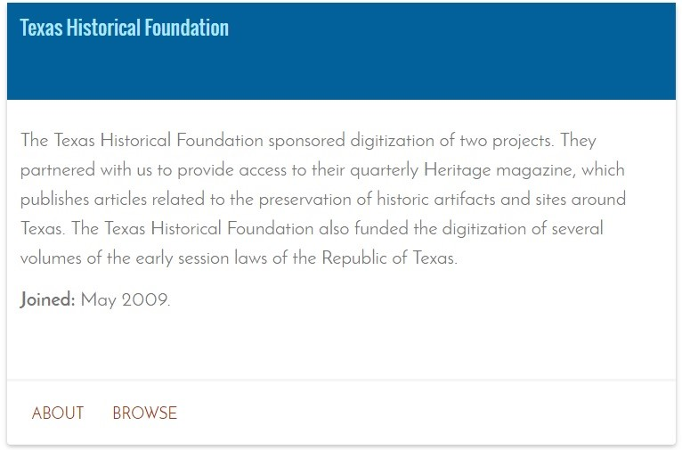
Better short description:
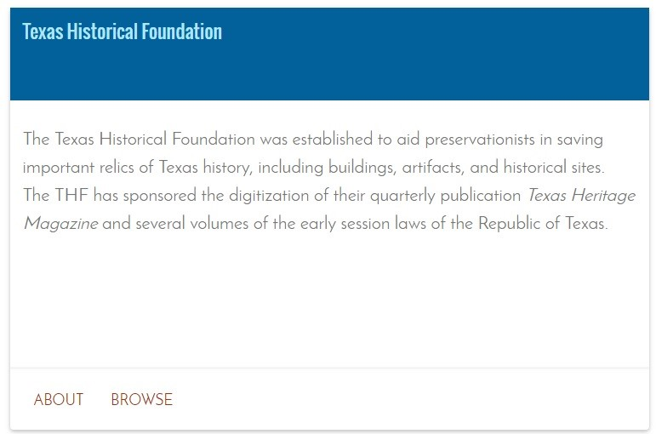
Original long description:
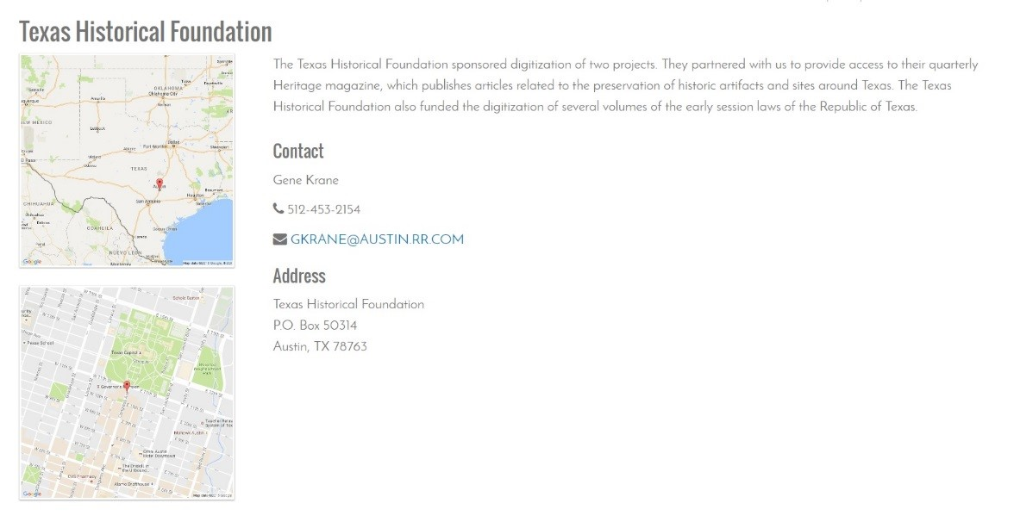
Better long description:
