Welcome, UNT Students!

Looking for a job on campus? Want to gain work experience and skills to develop your professional resume? Come work at the library! We value a diverse and inclusive workforce and have many student assistant positions available on the Handshake site throughout the year.

Working for the library is a great way to develop a variety of workplace skills and no previous library experience is required for many of our roles. We’ve created a step-by-step guide to the process. This includes: getting your application sent off, seen by the hiring manager, and what to expect after you have applied.

Step 1: Find a job you are interested in on Handshake

What you’ll need:

- A computer and access to the internet
- Student Employment Application to upload
- Resume
- Cover letter which addresses the job description
- Any other required documents or items as noted in the official job posting
TIP: It is important to tailor your resume or cover letter to the position you are applying for. Check out the Career Center’s guides here: careercenter.unt.edu/resources/virtual-workshops-and-events/

Let’s Get Started!
- Go to the UNT Handshake site.

- Click on Student Login to reach the UNT Handshake login page.
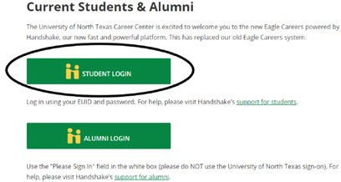

- Select Active UNT Students Login Here and sign in with your EUID and Password.

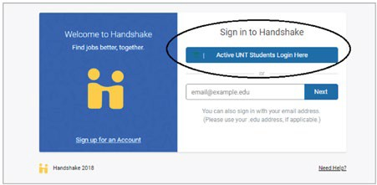

- Select Jobs at the top of the screen.

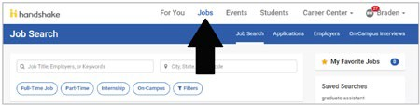

- Search Libraries in the search box and click on the Part-Time and On- Campus filters. All jobs in the libraries should be visible now.
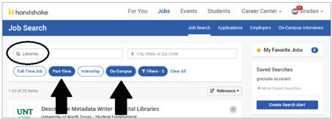

- Click on the job that appeals most to you.

- Be sure to read the job description before choosing to apply!

Step 2: Apply for job you are interested in on Handshake
Managers will only accept resumes and expressions of interest for the job through Handshake.

- To apply, select the green Apply button to the right of the application deadline.
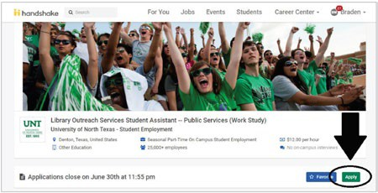

- An Apply to University of North Texas - Student Employment window should pop up that will allow you to upload your application materials. We strongly recommend using the Upload New button to upload your customized materials that address your specific job description.

TIP: Materials specifically tailored to address job advertisements and descriptions may help bump you to the top of the list.

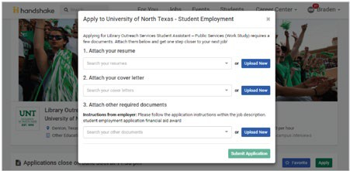

Once your materials have uploaded to the system, select “submit application.” And now you have completed applying through Handshake!

Tip: Due to the high volume of applications received, we are unable to communicate with each applicant individually regarding the status of their application. Please do not contact library staff about individual application status. Applicants will be notified by the hiring manager if selected for an interview.

Step 3: How to make the best impression
Read the application instructions closely for each job you apply for. If there are specific instructions and you do not follow them, the managers first impression of your application may be that you did not pay attention to the details or follow the instructions.

Customize your resume and cover letter to the job you are applying for. If you apply for a customer service role but your cover letter states how interested you are in a technology role, the hiring manager could think you accidentally applied to the wrong job or did not pay attention to the details. The UNT Career Center has great resources to help you make the best impression on hiring managers. This Resume Basics webpage is a good starting point.

Many job postings for library positions require you to provide additional application materials like work samples (i.e. writing samples, videos, and graphic design portfolios). These should be provided only if it is in the job posting or if directly requested by the hiring manager/selection committee.

Once you have applied in Handshake and submitted a copy of any/all requested materials, you will have completed the application process for your desired position. Congratulations!

After you have applied, there is no need to reach out to the hiring manager. They will contact you if they would like to talk to you further. Our student jobs sometimes get 600+ applicants for one job. Managers would much rather be reviewing your resume than fielding emails about the job.

Search committees may notify you of your application status through handshake or email, so be sure to check both places often. The selection process can take anywhere between a week to a month.

If you are selected to interview for a role, be ready to discuss what knowledge and skills you have in relation to the job you are interviewing for. We understand that you may not have direct job experience but if you are asked a question about how you solve problems, think about a time when you solved a problem in a non-work context like school, volunteer work or something else.

If you are not one of the top candidates, you may not be contacted until the job is filled. Not being contacted does not mean your application was bad or your knowledge and skills are inadequate. It simply means that there were others who applied were more qualified than you. If you apply for a similar position later, you could be one of the most qualified candidates.

